**Title: Decadal Biomass Growth Analysis of Key Algae Species in Chilika Lagoon (2015–2024)**

Authors: Sayed Umair Ali Affiliation: Pixxelraft Research Labs / FFS Institute of Ecological Engineering Date: July 2025 Location of Study: Chilika Lagoon, Odisha, India

## Abstract

This study presents a decadal simulation (2015–2024) of biomass accumulation in three ecologically and commercially relevant algae species in Chilika Lagoon. Leveraging real climate data from the NASA POWER database and a linear tolerance-based growth model, we analyzed biomass trends for *Ulva lactuca*, *Hypnea musciformis*, and *Caulerpa racemosa*. Our results show distinct growth responses, with *Hypnea musciformis* outperforming others in cumulative productivity, particularly during dry seasons. The findings offer practical guidance for sustainable aquaculture and climate-resilient marine farming in coastal Odisha.

## 1. Introduction

The global push toward sustainable aquaculture has made algae cultivation a critical area of focus, particularly in ecologically rich and climate-sensitive zones. Chilika Lagoon, Asia’s largest brackish water lagoon, is an ideal site for algae-based bioresource exploration due to its biodiversity and varying climate exposure. Understanding species-specific growth dynamics under real-world conditions is essential for optimizing productivity and ensuring environmental resilience. This study aims to simulate and compare biomass trajectories of three prominent algae species over a 10-year period, using real climatic inputs.

## 2. Materials and Methods

### 2.1 Study Area and Data Collection

* **Location:** Chilika Lagoon, Odisha, India
* **Timeframe:** 2015–2024 (monthly granularity)
* **Climate Data Source:** NASA POWER API
* **Variables Used:**
  + Monthly Maximum Temperature (TempMax_C)
  + Sunlight Duration (Sunlight_h)
  + Precipitation (for reference, not modeled directly)
  + Simulated Nutrient Levels (1.5–4.0; uniform random)

### 2.2 Algal Species

* **Ulva lactuca (Sea Lettuce):** Optimal Temp = 30°C, Nutrient = 3.0, Sunlight = 6h
* **Hypnea musciformis:** Optimal Temp = 28°C, Nutrient = 2.8, Sunlight = 7h
* **Caulerpa racemosa:** Optimal Temp = 32°C, Nutrient = 4.0, Sunlight = 5h

### 2.3 Biomass Growth Model

A simplified linear model based on tolerance windows:

#### Growth Equation:

Biomass(t+1) = Biomass(t) * 0.9 + 80 * (T_score * N_score * S_score)

Where: - T_score = max(0.01, 1 - |Temp - T_opt| / T_tol) - N_score = max(0.01, 1 - |Nutrient - N_opt| / N_tol) - S_score = max(0.01, 1 - |Sunlight - S_opt| / S_tol)

Tolerance values vary by species and were tuned to reflect ecological sensitivity.

### 2.4 Tools and Software

* Language: Python 3.10
* Libraries: pandas, NumPy, seaborn, matplotlib
* Data Pipeline: Climate CSV → Simulated Nutrients → Growth Loop → Output CSV

## 3. Results

### 3.1 Biomass Growth Trends

Monthly biomass values were simulated and visualized for each species:

* **Ulva lactuca:** Showed periodic growth surges, particularly in late 2024, but was highly sensitive to temperature deviations.
* **Hypnea musciformis:** Achieved the highest overall biomass. It responded positively to moderate nutrient and sunlight conditions, peaking in dry months.
* **Caulerpa racemosa:** Demonstrated consistent but slower biomass growth, indicative of ecological robustness but lower productivity.

### 3.2 Visualization

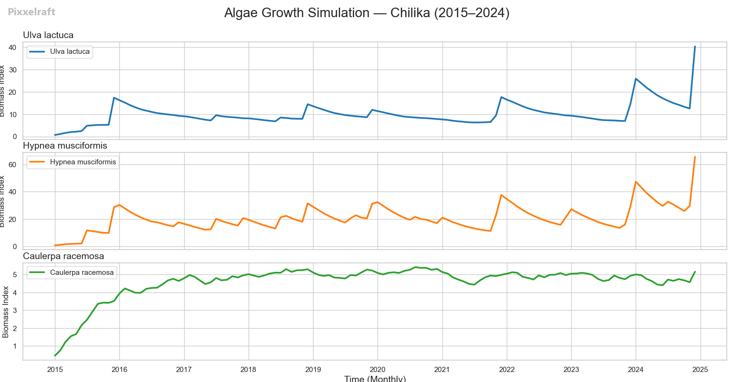

Three separate time-series plots were generated using seaborn subplots. Biomass values were annotated by date for each species. The final plot offers insight into interspecies variability across a decade.

## 4. Discussion

This simulation highlights the complex relationship between climate variables and algal biomass accumulation. The species-specific tolerance model allowed us to differentiate high-yield candidates from resilient yet slow growers.

* **Hypnea musciformis** stands out for commercial scalability due to its yield stability and climate alignment.
* **Ulva lactuca** could be useful for seasonal harvesting but requires tight environmental control.
* **Caulerpa racemosa** may be ideal for systems facing unpredictable climate shocks due to its resilience.

Limitations include the use of simulated nutrient data and simplified scoring functions. Future models can integrate pH, salinity, and machine learning-based optimization.

## 5. Conclusion

From 2015 to 2024, *Hypnea musciformis* emerged as the most productive algae species under real climate data from Chilika Lagoon, followed by *Ulva lactuca*. *Caulerpa racemosa* showed stable but lower biomass levels. This work supports strategic algae species selection for biofuel, food, and pharmaceutical applications in coastal India.

## References

1. NASA POWER Climate Data: https://power.larc.nasa.gov/

## Appendix

* **Raw Climate Data File:** odisha_climate.csv
* **Simulation Output:** odisha_climate_with_biomass.csv
* **Code Repository:** /simulator/algae_simulator.py
* **Visualization Tool:** Python (matplotlib/seaborn)

End of Paper